Project acronym: FERMI
Project full title: Fake nEws Risk Mitigator
Call identifier HORIZON-CL3-2021-FCT-01
Start date: 01/10/2022
End date: 30/09/2025
Grant agreement no: 101073980

[Communication Starter Pack]

Work package: 6
Version: 0.9
Deliverable type: N/A Dissemination level: Confidential
Official submission date: N/A Actual submission date:

Leading author(s):
Surname | First name | Beneficiary
Paciaroni | Alessandro | LC
Mureddu | Francesco | LC

Contributing partner(s):
Surname | First name | Beneficiary
Fikenscher | Sven-Eric | HfoD

Peer reviewer(s):
Surname | First name | Beneficiary

Ethics reviewer:
Surname | First name | Beneficiary

Security reviewer:
Surname | First name | Beneficiary

Document Revision History

Version | Date | Modifications Introduced
 |  | Modification Reason | Modified by

Executive summary

This document constitutes the communication starter pack for the Horizon Europe project FERMI. The purpose of this document is to present the latest version of preliminary communication and dissemination material, channels, and resources. More specifically, this document provides the FERMI consortium members with an overview of the material that will be delivered as part of Work Package 6 so as to allow early monitoring of the work package activities and the beginning of communication activities.

Table of Contents
Executive summary 3
Table of Contents 4
List of figures and/or list of tables 5
Abbreviations 6
1 Introduction 7
2 FERMI identity 8
2.1 Visual identity of the project 8
2.2 Templates 15
3 Social media accounts of the project 17
3.1 Presentation of the project FERMI 19
4 Dissemination and communication channels and stakeholders 21
4.1 List of events 21
4.2 List of journals and other avenues for publication 21
4.3 List of stakeholders 21
5 Website of the project FERMI 23
5.1 Structure of the website 23
6 Conclusions 24
List of References 25
Annex A Enter annex title here 26

List of figures and/or list of tables

Image 1 - FERMI logo 8
Image 2 - FERMI colours 9
Image 3 - Roll-up 10
Image 4 - Poster FERMI 11
Image 5 – Flyer (one) 12
Image 6 - Flyer FERMI (two) 13
Image 7 - Brochure external 14
Image 8 - Brochure internal 15
Image 9 - Deliverable template 15
Image 10 - FERMI on Mastodon 17
Image 11 - FERMI on Twitter 18
Image 12 - FERMI on LinkedIn 19
Image 13 - FERMI on YouTube 19
Image 14 - Presentation first slide Image 15 - Presentation intro 20
Image 16 - Presentation section title Image 17 - Presentation content slide 20
Image 18 - Form for contribution to dissemination, communication and stakeholder engagement 21
Image 19 - Website placeholder 23

Abbreviations
A list of abbreviations in alphabetical order is strongly recommended. See the following example.

GA: Grant Agreement
FERMI: Fake nEws Risk MItigator

- Introduction
The communication starter pack is a first set of resources for the dissemination and communication of the Horizon EU project FERMI (Fake nEws Risk Mitigator). The objective of the communication starter pack is to provide the FERMI consortium with an overview of the communication channels and tools that have been developed until M02 of the project timeline. The production of a communication starter pack is justified by the necessity to begin communication activities at early stages of the project timeline, although the complete set of resources for dissemination and communication activities is due at a later stage (i.e., M06).
The communication starter pack includes the following: overview of visual identity, social media, templates, website placeholder, dissemination and communication channels, tools and resources.
- FERMI identity
  - Visual identity of the project
The visual identity of FERMI was developed starting from the following questions:
- How reliable is your news source?
- Who is behind and who certifies the news?
Therefore, the choice of the following keywords:
- Credibility
- Reliability
This choice drove the designers in the ideation and development of FERMI visual identity. This resulted in the following logo:
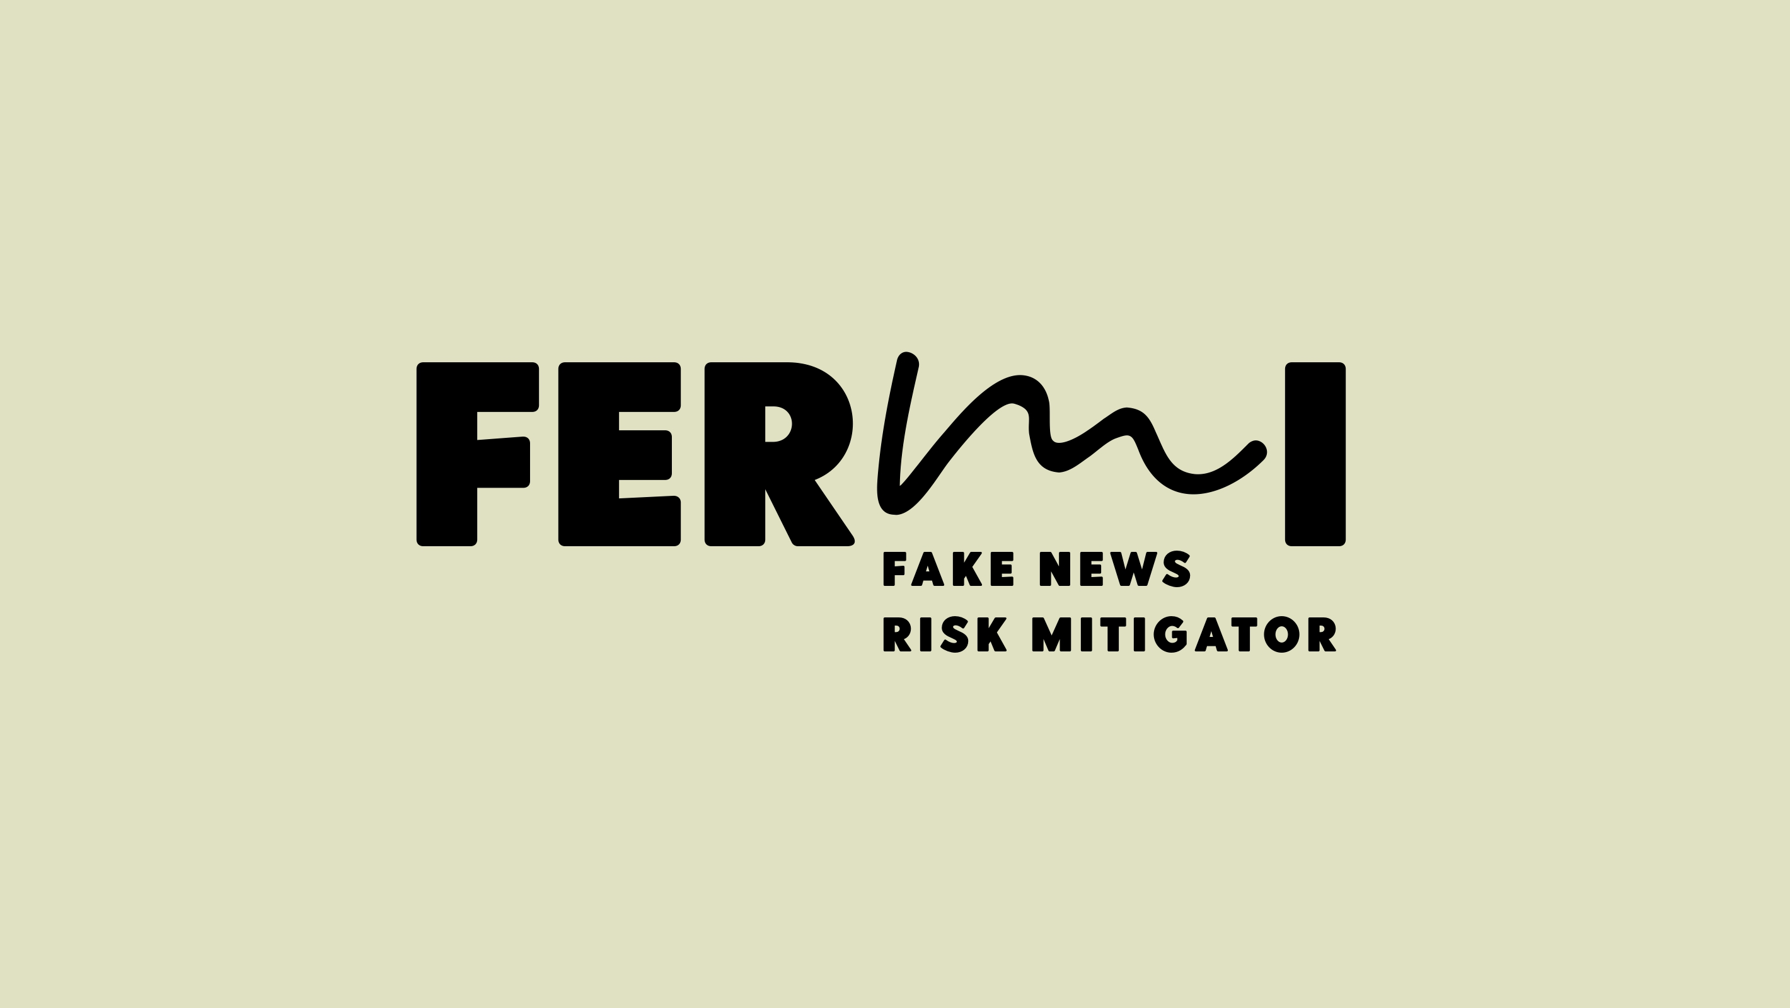
Image 1 - FERMI logo
The visual identity was developed using three colours, these can be seen in the following image together with their RGB codes. However, the colour choice presented in Image 1 -i.e., black logo on beige background- is the preferred one. Second in order of preference is the reversed choice -i.e., beige logo on black background. These options should be preferred to any other option whenever possible.
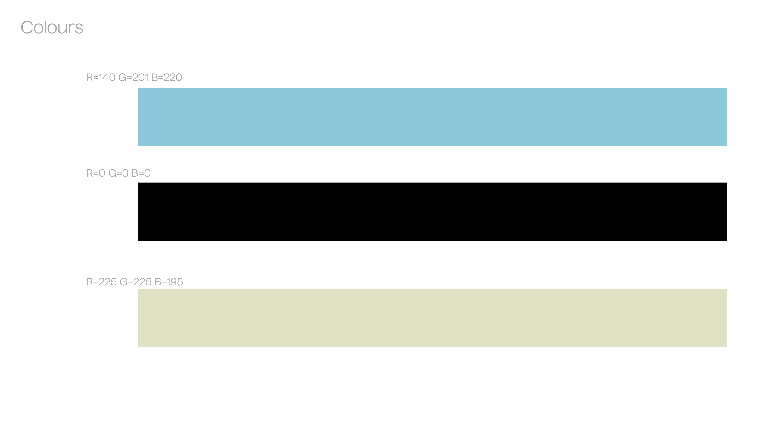
Image 2 - FERMI colours
Hence, the logo presented in Image 1 is available in the three colours showed in Image 2.

The current version of the roll-up is the following:
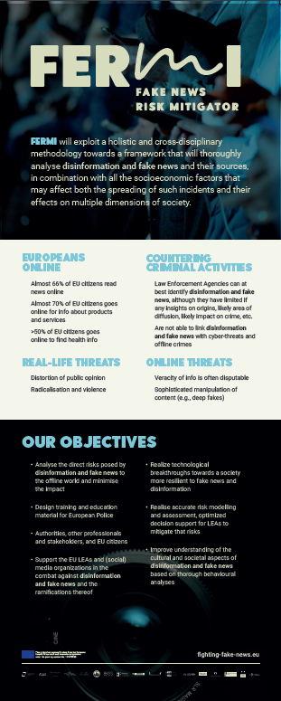
Image 3 - Roll-up
The roll-up will be printed and exposed in suitable events. The roll-up provides a summary of FERMI as for its main output, the project motivation and the key objectives.
The FERMI poster is shown in the image below.
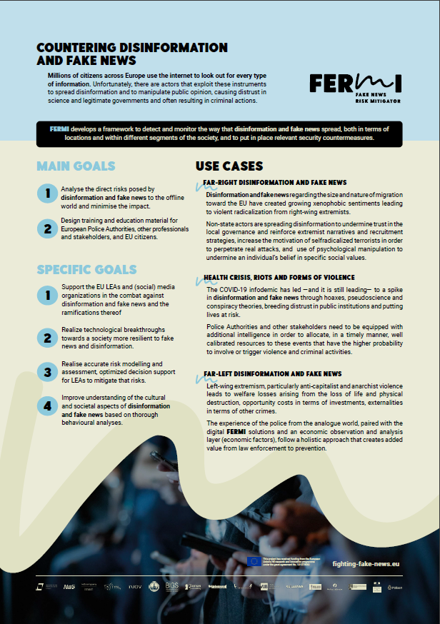
Image 4 - Poster FERMI
The poster will be produced only in digital format and distributed as such. The poster offers an overview of the project that highlights the problem that FERMI identified and aims to solve and its value proposition. Moreover, it outlines the use-cases where FERMI solutions will be deployed and tested so as to give the reader a glimpse of the concrete application of FERMI.
The following is the current version of the flyer developed for FERMI project.
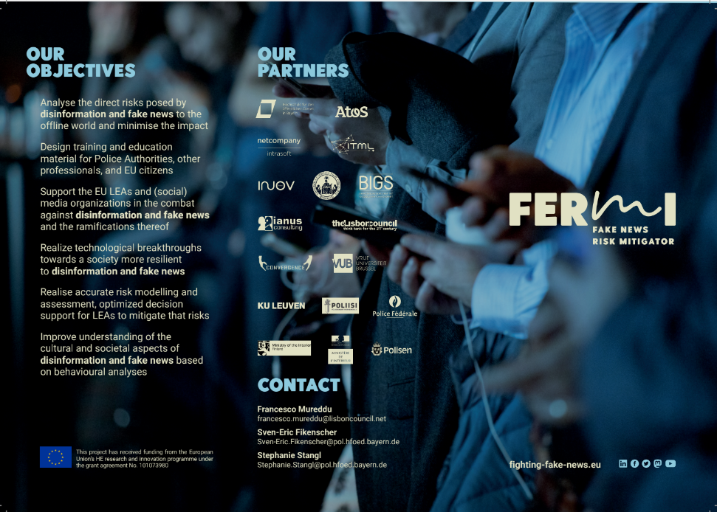
Image 5 – Flyer (one)
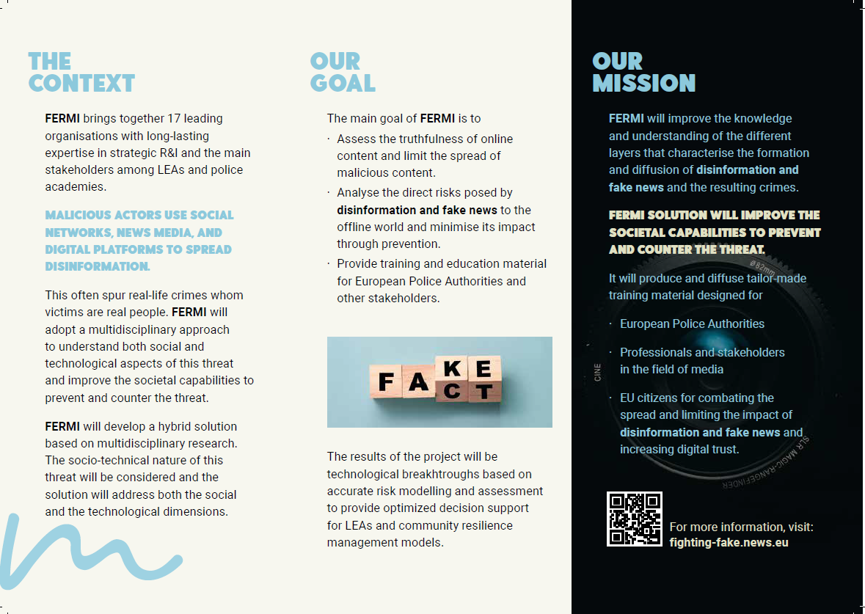
Image 6 - Flyer FERMI (two)
The flyer will be printed and distributed in suitable events. Additionally, it can also be distributed in a digital format.
The current version of the brochure is shown in the following images.
Image 7 - Brochure external
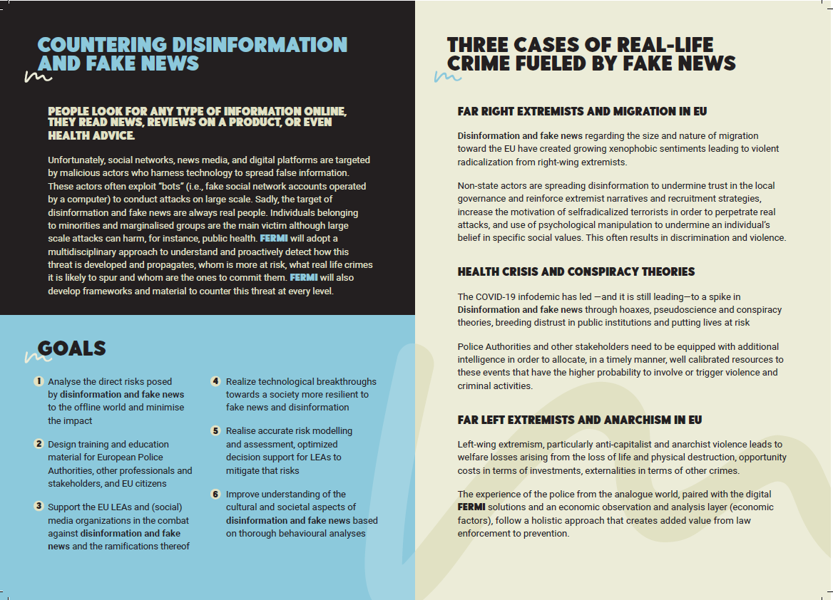
Image 8 - Brochure internal
The brochure will be printed and distributed mainly in such format. The brochure will be distributed at every suitable event organised by the project consortium and ideally also attended by at least one of the partners. The brochure combines an appealing aesthetic on its external side with rich information on the internal side. The content aims to help the reader building a clear understanding of the problem identified by the project and the envisioned solution. The brochure highlights the real-life scenarios where this problem can be witnessed and addressed.
  - Templates
A template for the deliverable was developed. This can be seen in the following image.
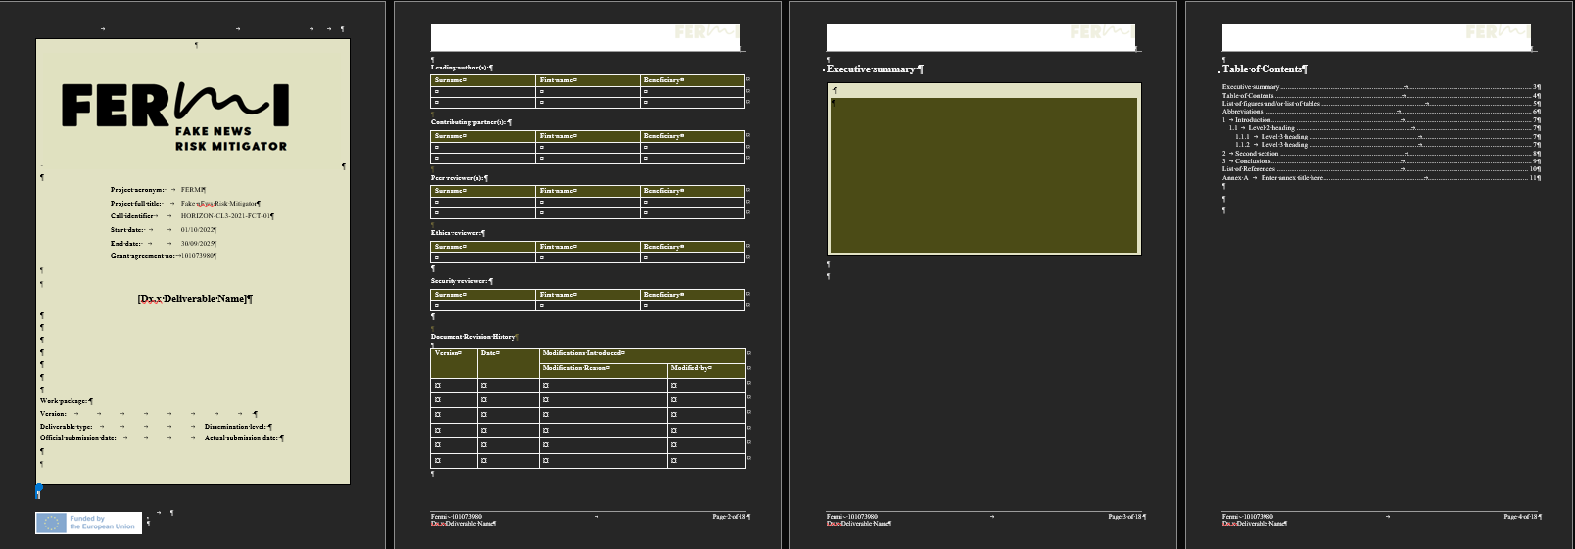
Image 9 - Deliverable template
The current version of the template for deliverables does not have a cover page. The first page of the current version, visible in Image 16, consists of the logo and key information regarding the project FERMI and the document such as the Horizon Europe funding call identifier and the type of deliverable. The option to include a deliverable template with an aesthetically pleasing cover page will be explored in the first months of the project. This version of the deliverable template may be used for dissemination and external communications.
- Social media accounts of the project
The creation of social media accounts was foreseen for the online presence of FERMI project. Regarding the social media an account was created on Twitter, LinkedIn, YouTube and Mastodon.
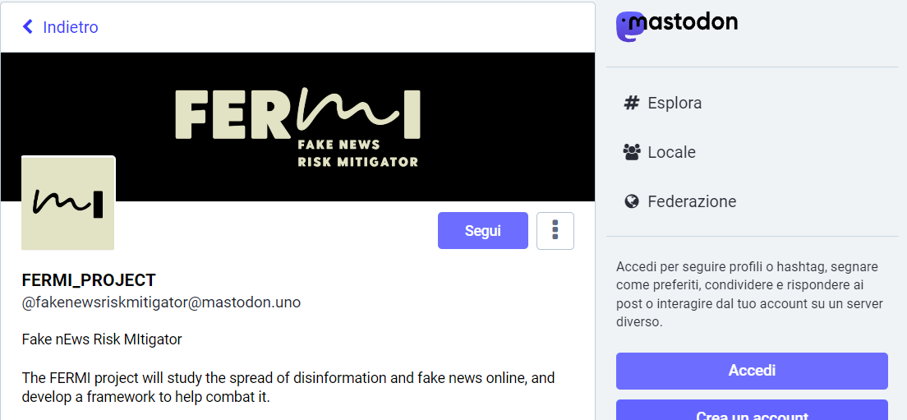
Image 10 - FERMI on Mastodon
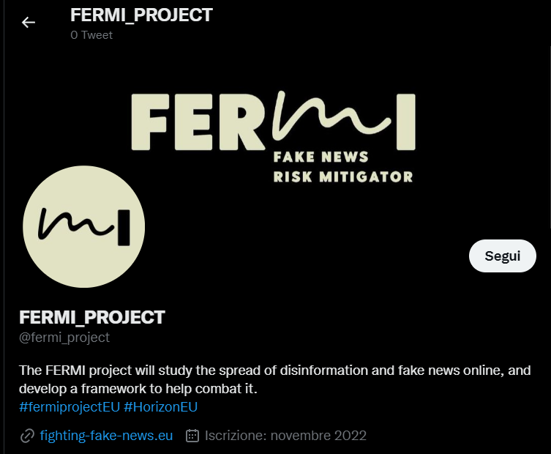
Image 11 - FERMI on Twitter
Twitter will be foremostly used to share news and flash updates on the happenings related to the project and its domain.
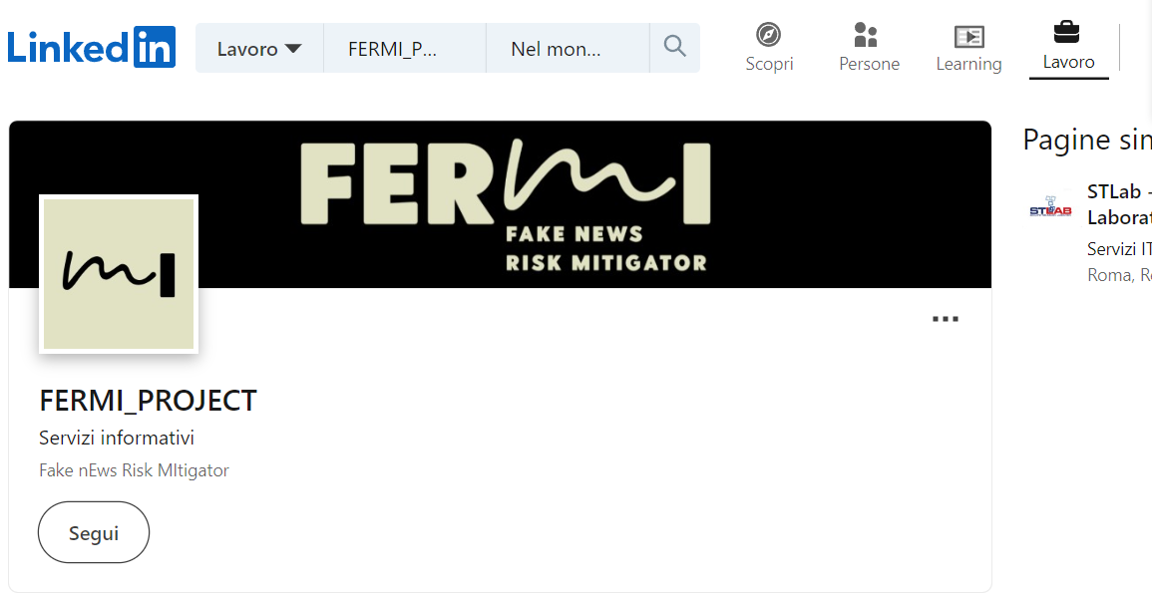
Image 12 - FERMI on LinkedIn
LinkedIn will be foremostly used to engage with the community of professionals surrounding FERMI.
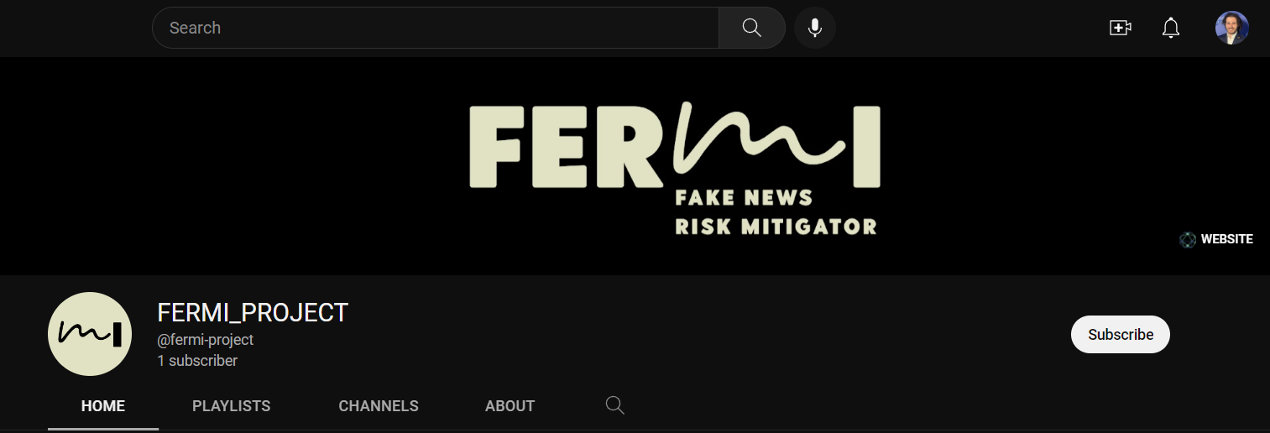
Image 13 - FERMI on YouTube
YouTube will be foremostly used to share videos of conferences, webinars, roundtables and other happenings organised within the project. Additionally, it will serve as a platform for sharing brief videos to explain the project.
  - Presentation of the project FERMI
A presentation to introduce the project was developed based on the visual identity. Screenshots of some slides follow.
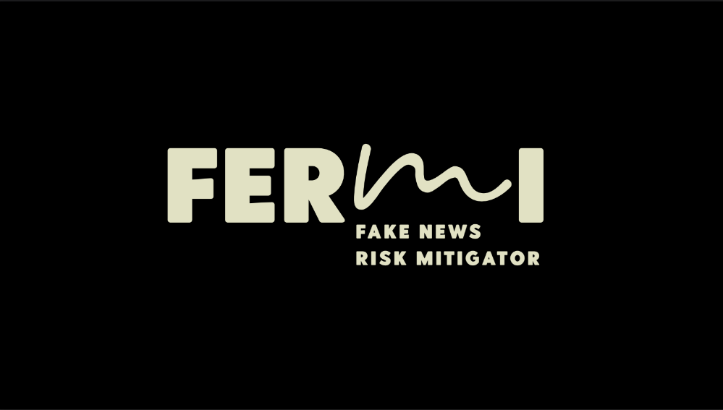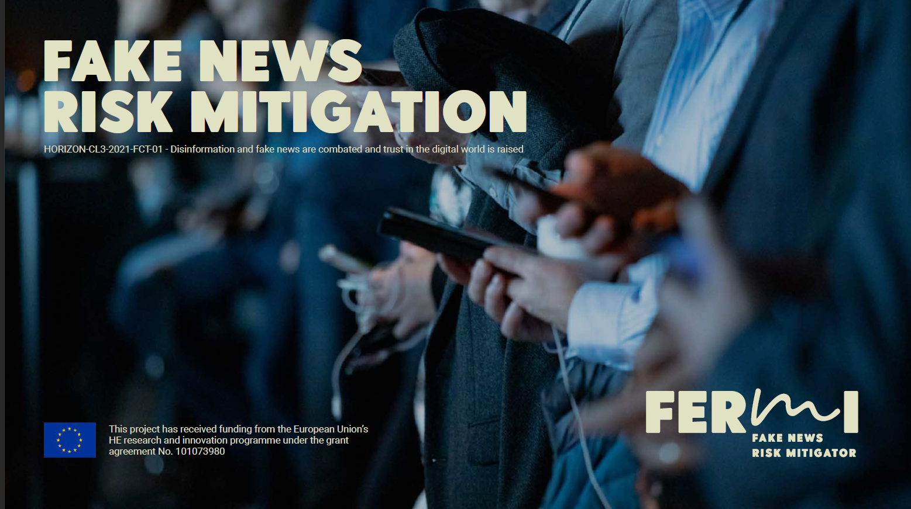
Image 14 - Presentation first slide Image 15 - Presentation intro
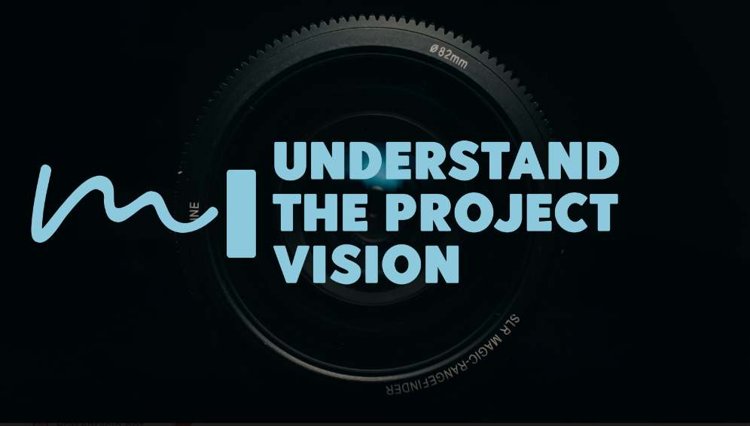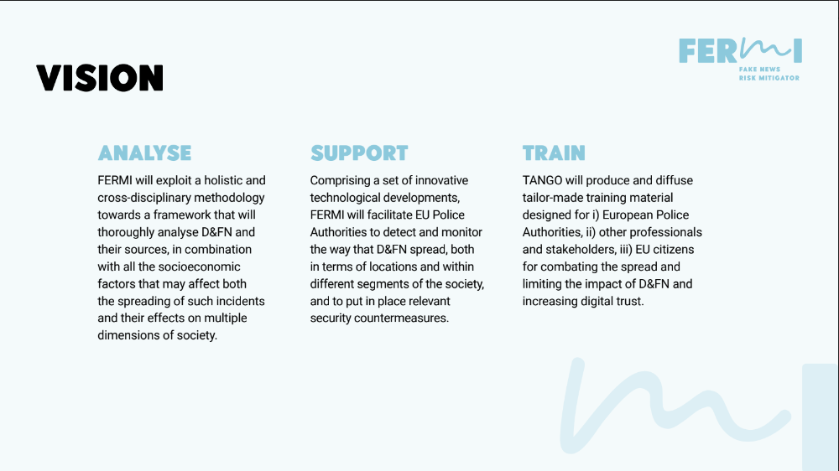
Image 16 - Presentation section title Image 17 - Presentation content slide
The presentation will be distributed and used to introduce the project. Further ahead in the project timeline more specific presentations can be developed based on the FERMI consortium needs and objectives. A template is developed based on the introductory presentation.
- Dissemination and communication channels and stakeholders
The communication starter pack includes an overview of the main channels for communication and dissemination of the FERMI project. These are divided into events, journals and other avenues for publication, and stakeholders. The lists presented here are by no means exhaustive. In fact, they will be further expanded with the contribution of the FERMI consortium members. Partners will be asked to contribute through a form similar to the one showed in the following image.
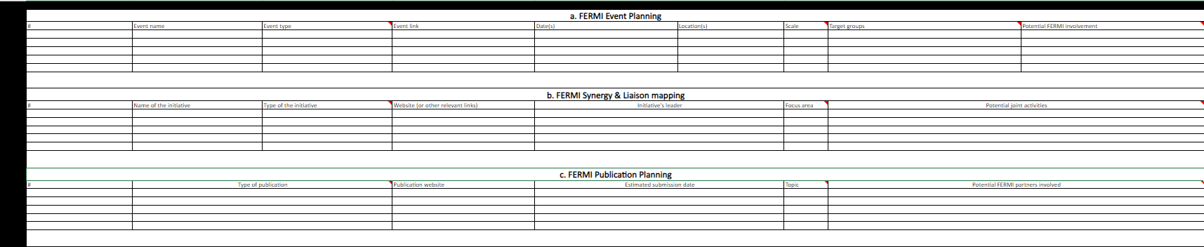
Image 18 - Form for contribution to dissemination, communication and stakeholder engagement
Potential stakeholders will be targeted by the FERMI consortium members and directly asked to enrol as stakeholders of the project. This will ensure compliance with the General Data Protection Regulation of the European Union.
  - List of events
Intelligence Support Systems for Electronic Surveillance, Social Media/DarkNet Monitoring and Cyber Threat Detection, 6-8 June 2023, Prague (CZ).
ISS World Europe is the world's largest gathering of Regional Law Enforcement, Intelligence and Homeland Security Analysts, Telecoms as well as Financial Crime Investigators responsible for Cyber Crime Investigation, Electronic Surveillance and Intelligence Gathering.
The 23rd Annual Conference of the ESC (EUROCRIM), 6-9 September 2023, Florence (IT).
EU DisinfoLab 2023 Annual Conference, 11-12 October, Krakow (PL).
EU DisinfoLab is an independent non-profit organisation focused on tackling sophisticated disinformation campaigns targeting the EU, its member states, core institutions, and core values.
European Intelligence and Security Informatics Conference.
  - List of journals and other avenues for publication
- arXiv
- OpenAIRE
- Springer
- euvsdisinfo.eu
- International Journal of Critical Infrastructures
- European Journal on Criminal Policy and Research
- International Journal of Critical Infrastructure Protection
- European Journal for Security Research
  - List of stakeholders
European Union funded projects are the first target in order to develop synergies and open the way to collaborative actions. Since the stakeholder enrolment has not started yet, the list presented here is limited to projects and initiatives and does not include natural persons. This is in compliance with the General Data Protection Regulation which would otherwise require the informed consent of said natural persons to be enlisted as stakeholders of the project.
- SENTINEL
- ROXANNE
- MARVEL
- OSiMa
- WISIND
- ENSURESEC
- Policy Cloud
- Cyber-TNOC
- DATACORS
- EUNOMIA
- Medi@4sec
- Website of the project FERMI
The Horizon Europe project FERMI will also establish its online presence through a website. This will be a pivotal channel for communication and dissemination of the project’s activities, findings, and results. Additionally, it will offer the opportunity to stakeholders to register as such and to follow the developments throughout the project duration. In other words, the website will be akin to a single point of contact for all information related to FERMI project.
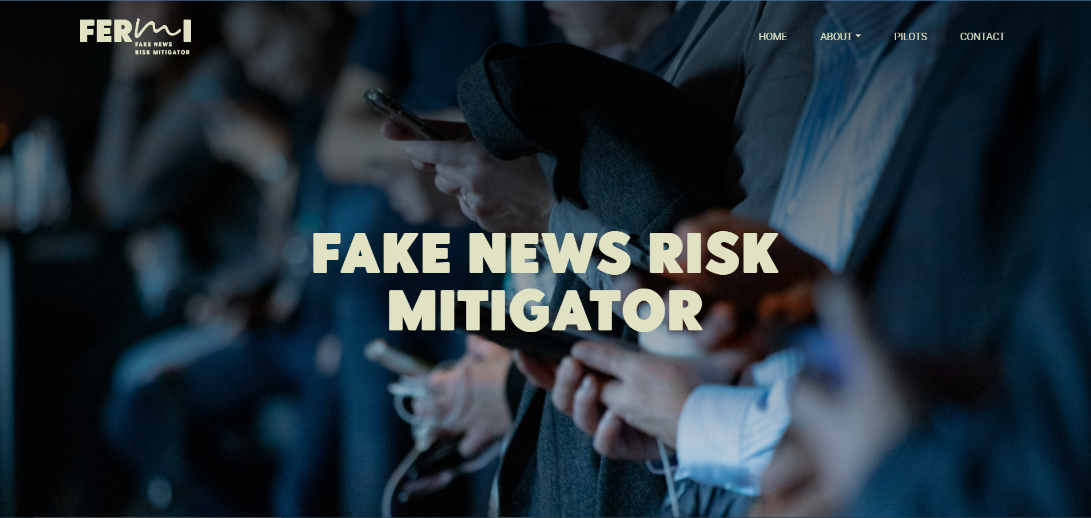
Image 19 - Website home page (opening view)
  - Structure of the website
The first version of the website structure includes:
- Home page
- About
  - Description of the project
  - Partners
  - Governance
- Pilots
- Contact
Whereas the Home page provides an overview of the project and, naturally, functions as a link to the other sections of the website, the other sections dive deeper into the project.
The About section includes a page that describes the project’s context, the issue addressed, the solution advanced and more specific objectives of FERMI. Additionally, it includes a page about the consortium partners, these are presented and briefly described. Finally, it includes a page on the governance of the project, hence a description of the work packages and the leadership team (i.e., project’s coordinator, dissemination manager, quality manager, etc.).
The section about the Pilots gives access to the three pilot cases of FERMI. The current version of the website offers a high-level overview of the pilots. However, this section is likely to be the object of the first website update.
Finally, the Contact page. This page evidently includes the contact information of key roles within FERMI.
- Conclusions
The communication starter pack is a first set of resources for the dissemination and communication of the Horizon EU project FERMI. The communication starter pack provides an overview of the communication channels and tools that have been developed. As a matter of fact, the communication starter pack constitutes an input to the deliverable 6.1 “The FERMI outreach management facilitators package”.
The communication starter pack includes the following: overview of visual identity, social media, templates, website, dissemination and communication channels, tools, and resources

List of References

- Enter annex title here

